**MIE1622 Assignment 4 Report**

**Kaiyan Jiang 1003848189**

**April 8, 2022**

**Introduction:**

In this assignment, three pricing functions are implemented: Black-Scholes pricing formula for European option, Monte Carlo pricing procedure for European option and Monte Carlo pricing procedure for Barrier knock-in option.

For the Monte Carlo pricing procedure, the number of scenarios is 1000000 and the number of time steps are 1 and 10, which refer to a one-step Monte Carlo pricing procedure and a multi-step Monte Carlo pricing procedure.

First, the price of both call and put option for the three pricing functions are computed. Charts are plotted to demonstrate the one-step Monte Carlo pricing procedure and the multi-step Monte Carlo pricing procedure.

**Analyze Results:**

Output:

Black-Scholes price of a European call option is 8.021352235143176

Black-Scholes price of a European put option is 7.9004418077181455

One-step MC price of a European call option is 8.008371126403206

One-step MC price of a European put option is 7.893958348746839

Multi-step MC price of a European call option is 8.017173797995046

Multi-step MC price of a European put option is 7.889467066568246

One-step MC price of a Barrier call option is 7.81490911544863

One-step MC price of a Barrier put option is 0.0

Multi-step MC price of a Barrier call option is 7.9542193711753795

Multi-step MC price of a Barrier put option is 1.1965951845188583

Distribution of Simulated Price at Maturity and Geometric Random Walk Paths for One-step Monte Carlo Simulation:

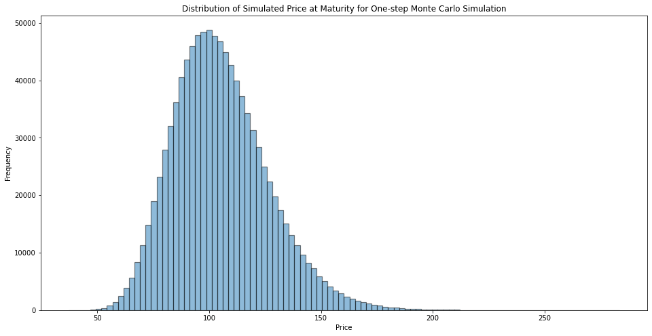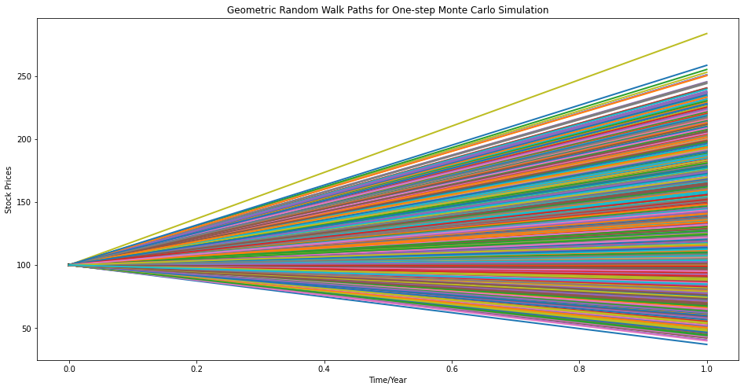

Figure 1: Distribution of Simulated Price at Maturity and Geometric Random Walk Paths for One-step Monte Carlo Simulation

Distribution of Simulated Price at Maturity and Geometric Random Walk Paths for Multi-step Monte Carlo Simulation:

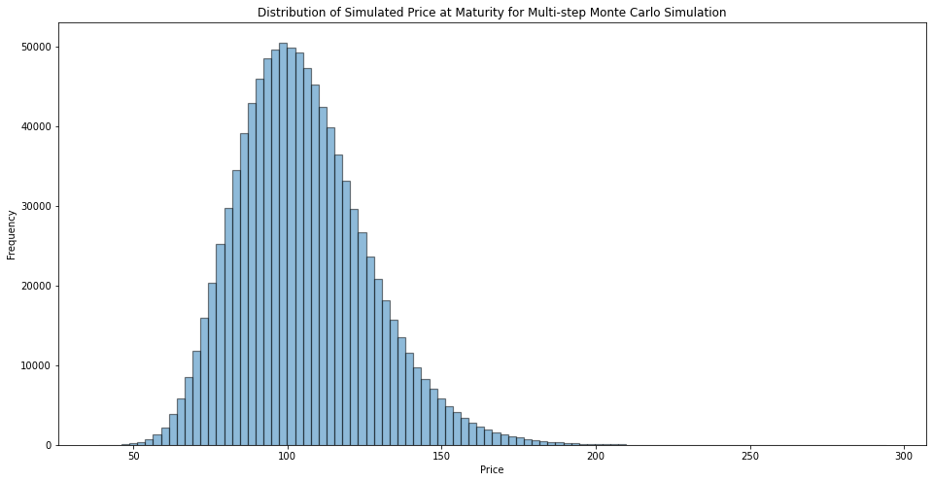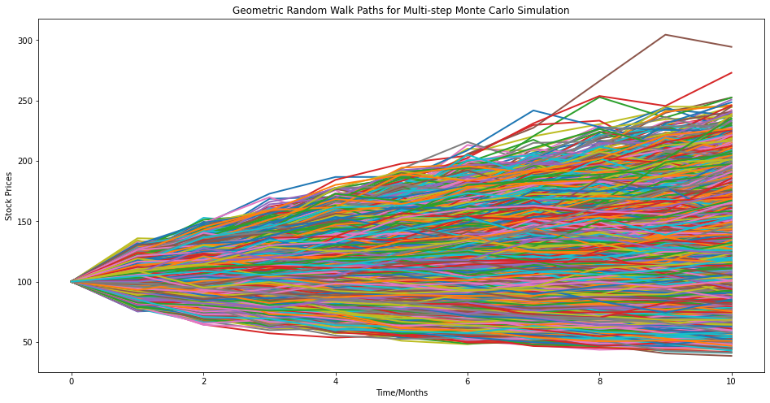

Figure 2: Distribution of Simulated Price at Maturity and Geometric Random Walk Paths for Multi-step Monte Carlo Simulation

Compare three pricing strategies for European option:

|  |  |  |
| --- | --- | --- |
| **Black-Scholes** | Call | 8.0214 |
| Put | 7.9004 |
| **One-Step Monte Carlo** | Call | 8.0084 |
| Put | 7.8940 |
| **Multi-Step Monte Carlo** | Call | 8.0172 |
| Put | 7.8895 |

Among the three pricing procedures, the Black-Scholes strategy has the highest prices for both call and put options; the prices are 8.0214 and 7.9004, respectively.

The prices for the two Monte Carlo strategies are close for both the European call and the European put option. The Multi-step Monte Carlo strategy has a higher European call option price, and the One-step Monte Carlo strategy has a higher European put option price.

Thus, overall Black-Scholes has the best performance in European call option and European put option.

Diﬀerence between call and put prices obtained for European and Barrier options:

|  |  |  |  |
| --- | --- | --- | --- |
| **European** | **Black-Scholes** | Call | 8.0214 |
| Put | 7.9004 |
| **One-Step Monte Carlo** | Call | 8.0084 |
| Put | 7.8940 |
| **Multi-Step Monte Carlo** | Call | 8.0172 |
| Put | 7.8895 |
| **Barrier** | **One-Step Monte Carlo** | Call | 7.8149 |
| Put | 0.0 |
| **Multi-Step Monte Carlo** | Call | 7.9542 |
| Put | 1.1966 |

Unlike the call option prices and put option prices for European options, the Barrier call option prices and put option prices have a great difference. The Barrier call option prices are slightly lower than European call option prices, 7.8149 for One-step Monte Carlo and 7.9542 for Multi-step Monte Carlo, while the call option prices for European options are around 8.

The prices of the Barrier put option are extremely low, 0.0 and 1.1966 for One-step Monte Carlo and Multi-step Monte Carlo, respectively. In contrast, the prices of European put option are around 7.8-7.9.

Since the barrier is $110 and the spot price is $100, this is a up-and-in option. And as the barrier is greater than the strike price $105, the Barrier call option will almost all have a positive payoff. However, once the stock price fluctuating between barrier and strike price, the Barrier option will be worthless. That is why the call option prices for Barrier option are lower than for European option.

For Barrier put option, as the barrier is greater than the strike price $105, no one will be willing to sell at the strike price. Thus, this could explain why the prices of Barrier put option are so small, and close to 0.

Compute prices of Barrier options with volatility increased and decreased by 10% from the original input:

Original Input:

One-step MC price of a Barrier call option is 7.81490911544863

One-step MC price of a Barrier put option is 0.0

Multi-step MC price of a Barrier call option is 7.9542193711753795

Multi-step MC price of a Barrier put option is 1.1965951845188583

When volatility increased 10%:

One-step MC price of a Barrier call option with volatility increased by 10% is 8.640757113634919

One-step MC price of a Barrier put option with volatility increased by 10% is 0.0

Multi-step MC price of a Barrier call option with volatility increased by 10% is 8.750744880695345

Multi-step MC price of a Barrier put option with volatility increased by 10% is 1.504060715205732

When volatility decreased 10%:

One-step MC price of a Barrier call option with volatility decreased by 10% is 6.984621514446996

One-step MC price of a Barrier put option with volatility decreased by 10% is 0.0

Multi-step MC price of a Barrier call option with volatility decreased by 10% is 7.152543337765996

Multi-step MC price of a Barrier put option with volatility decreased by 10% is 0.9158359137206442

From the above results, when volatility increases, the prices are higher than the original results for both call and put options. And when the volatility decreases, the prices also decrease.

We may conclude that for higher volatilities, the stock prices are more likely to exceed the barrier and reach to higher level, thus, the prices for Barrier call and put options tend to be higher.

**Discuss possible strategies to obtain the same prices from two procedures:**

The procedure is designed as above figure. I use a loop to iterate the number of scenarios from 10 to 10000000. And since One-step Monte Carlo are less time-consuming, the number of time steps is chosen to be 1.

And the initial residuals are set to be $0.01 (1 cent) because the significance level are set up to cent. Thus, if the residual is smaller than 0.01, than it means that the Monte Carlo pricing for European option equals to Black-Scholes prices.

The output of the procedure is the following:

The optimal number of paths for call option is 1000000

The optimal one-step MC price of a European call option is 8.020305153289103

The absolute difference between optimal price and Black-Scholes results of a European call option is 0.00105

The optimal number of paths for put option is 1000000

The optimal one-step MC price of a European put option is 7.905618593022708

The absolute difference between optimal price and Black-Scholes results of a European put option is 0.00518

From the results, we can see that the absolute difference for both call and put option is smaller than $0.01 (1 cent), which fits our requirements. And for both options, the optimal number of scenarios is 1000000 and the number of time steps is 1.